Architecture DBQ

1. What is the definition of architecture? ____________________________________________________
_____________________________________________________________________________________
2. Vitruvius said architecture is a balance of ______________________, ___________________________
and __________________________________.
3. Combine your answers to #1 and #2 to write a brief summary of the reading.
_______________________________________________________________________________________
_______________________________________________________________________________________
_______________________________________________________________________________________
_______________________________________________________________________________________

PYRAMIDS

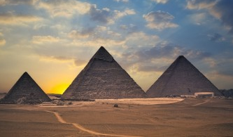
AZTEC
MAYA
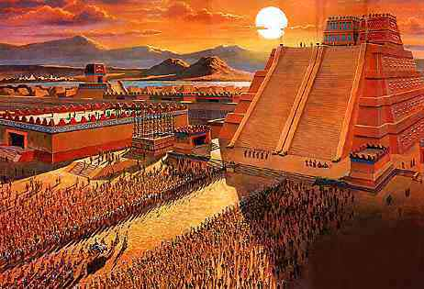
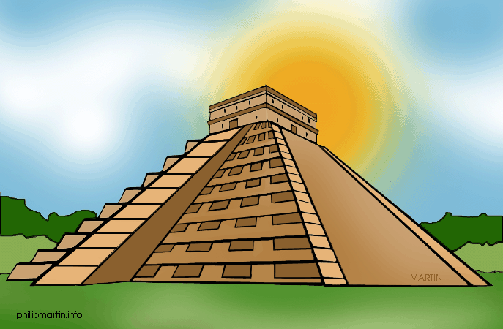
EGYPT

Click on one of the pyramids and answer the questions:

1. Describe the pyramid you chose with three adjectives _____________________________,
________________________________ and __________________________________.

2 Choose one of the three principles of Vitruvius that best applies to this pyramid.
____________________________________________________

3. Use your three adjectives to briefly explain why you chose your answer to #2.
_______________________________________________________________________________________
_______________________________________________________________________________________
_______________________________________________________________________________________
_______________________________________________________________________________________
_______________________________________________________________________________________
_______________________________________________________________________________________

TEMPLES

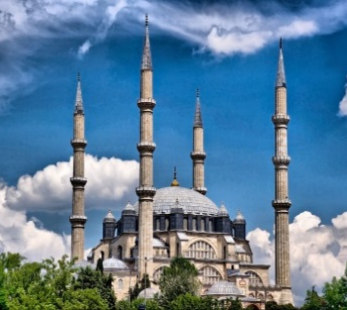
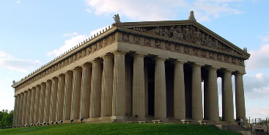
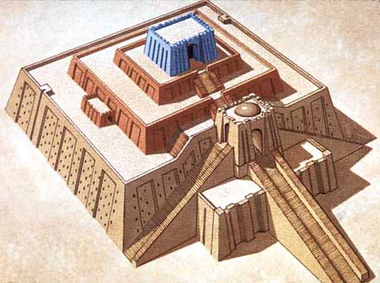

MESOPOTAMIAN
ZIGGURAT
ANCIENT GREECE
ISLAMIC MOSQUE

Click on one of the temples and answer the questions:

1. Describe how the temple you chose reflects the religious beliefs of the society that built it.
____________________________________________________________________________________
____________________________________________________________________________________
____________________________________________________________________________________
2. Was the temple you chose built by a monotheistic or a polytheistic society? (Circle one)

3. Use at least two complete sentences to explain how this temple might be different if it were built by a society that had the other type of religion. (For example, if it was built by a monotheistic society, how would it have been different if it was built by a polytheistic society?)
_______________________________________________________________________________________
_______________________________________________________________________________________
_______________________________________________________________________________________
_______________________________________________________________________________________
_______________________________________________________________________________________
_______________________________________________________________________________________
_______________________________________________________________________________________
_______________________________________________________________________________________

MONUMENTS

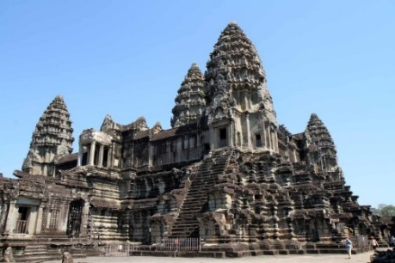
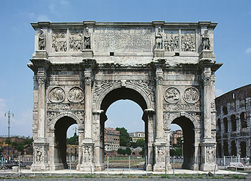
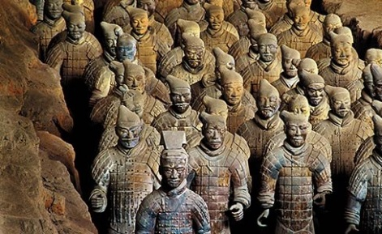

ANGKOR WAT
CAMBODIA
ANCIENT ROME
ARCH OF CONSTANTINE
ANCIENT CHINA
TERRACOTTA WARRIORS

Click on one of the monuments and answer the questions:
1. Describe how the monument you chose reflects the cultural values of the people that built it.
_____________________________________________________________________________________
_______________________________________________________________________________________
_______________________________________________________________________________________
2. Does this monument primarily relate to government, religion, or art? (Circle one)
3. In the first reading, architecture is described as “the meeting point of the need to build and the innate urge to communicate”. (Innate refers to something you are born with.) Describe how the monument you chose fits those two ideas.
How does it show that society’s need to build?
_______________________________________________________________________________________
_______________________________________________________________________________________
_______________________________________________________________________________________
How does it show that society’s need to communicate?
_______________________________________________________________________________________
_______________________________________________________________________________________
_______________________________________________________________________________________

Use the answers to all your previous questions to write a paragraph with the following topic sentence.
“Architecture reflects the values of civilizations, societies, and regions.”

In your paragraph, be sure to include:
- The topic sentence written above
- Supporting details about all three buildings you studied
- A reference to information from the article titled “What is architecture?”
- A closing statement in which you draw a conclusion.

__________________________________________________________________________________________________
__________________________________________________________________________________________________
__________________________________________________________________________________________________
__________________________________________________________________________________________________
__________________________________________________________________________________________________
__________________________________________________________________________________________________
__________________________________________________________________________________________________
__________________________________________________________________________________________________
__________________________________________________________________________________________________
__________________________________________________________________________________________________
__________________________________________________________________________________________________
__________________________________________________________________________________________________
__________________________________________________________________________________________________
__________________________________________________________________________________________________
__________________________________________________________________________________________________
__________________________________________________________________________________________________
__________________________________________________________________________________________________
__________________________________________________________________________________________________

Articles linked in the DBQ – next to each hyperlinked picture is a clipart of a small scroll. By clicking that scroll, the student will be taken to a brief article about the building shown in the picture.

Egyptian Pyramids
http://www.kidspast.com/world-history/0075I-pyramid-of-giza.php

Mayan Pyramids
http://www.ducksters.com/history/maya/pyramids_and_architecture.php

Aztec Pyramids
http://www.aztec-history.com/aztec-temples.html

Ziggurat
http://mesopotamia.mrdonn.org/ziggurats.html

Parthenon
http://study.com/academy/lesson/parthenon-facts-lesson-for-kids.html

Selimeye Mosque, Turkey
http://lostislamichistory.com/the-greatest-architect-of-all-time/

Terra Cotta Warriors, China
http://www.ducksters.com/history/china/terracotta_army.php

Arch of Constantine, Rome
http://www.ancient-rome-history-facts.com/Famous-Ancient-Roman-Architecture-Facts/Arch-of-Constantine-Facts.shtml

Angkor Wat, Cambodia
http://mocomi.com/angkor-wat/

