Satellite photo of Egypt and part of the Middle East
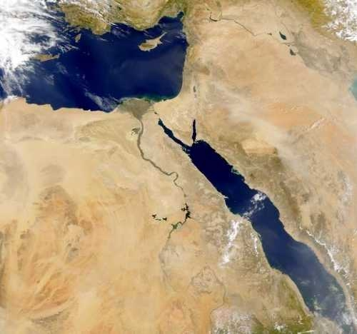

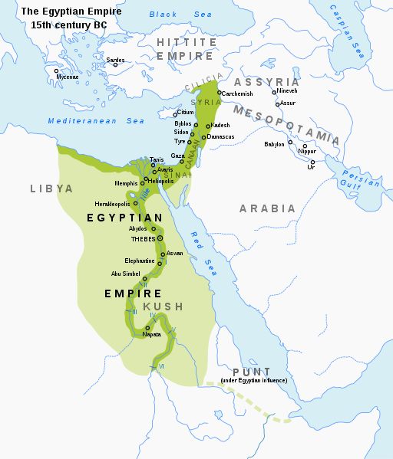
Map of the New Kingdom

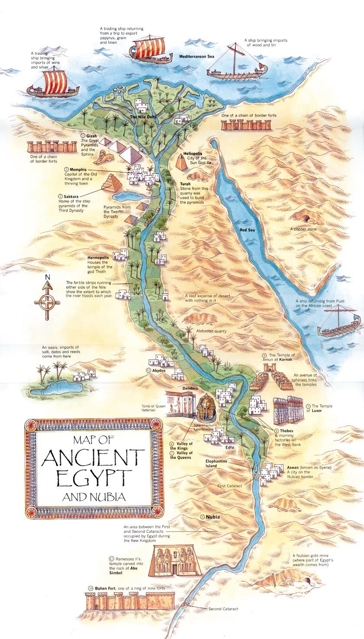
Map of important features and landmarks in Ancient Egypt

Map of natural resources in Ancient Egypt
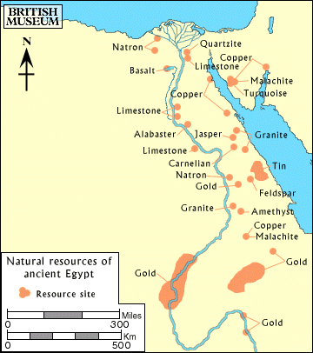

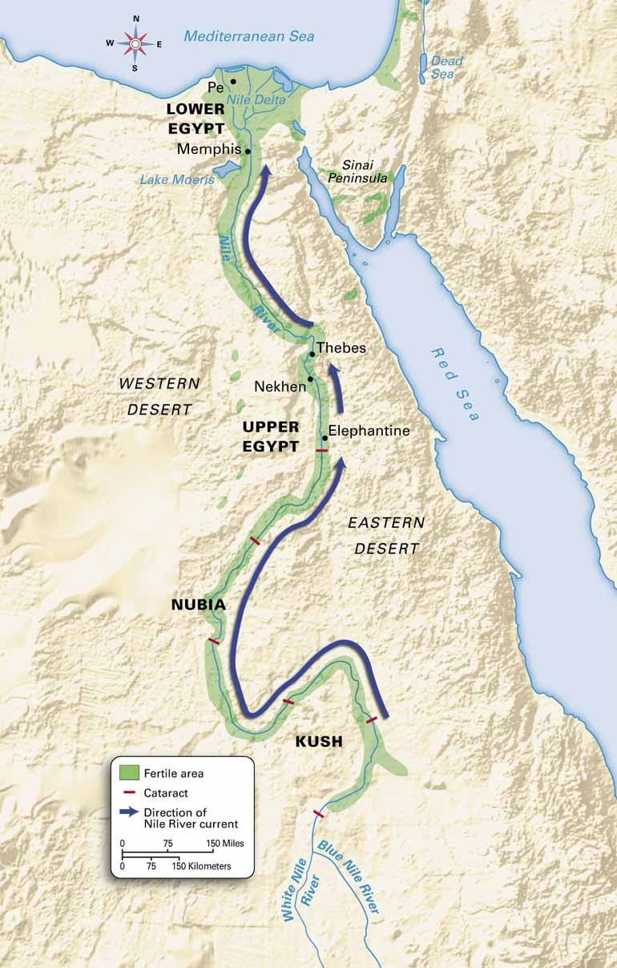
Map of the Nile River and Egypt's fertile land

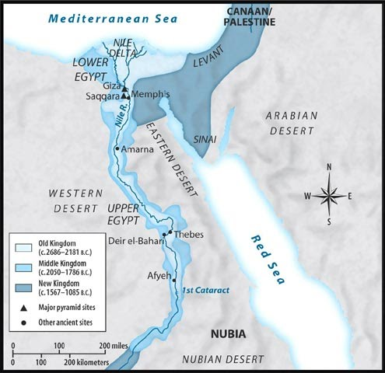
Map of the growth of the Ancient Egyptian Empire

