Picture  For each word create a “picture” that represents that word. Under each picture write a sentence that explains how the picture relates to the word.  This is the symbol for Taoism, it is also called ying & yang. | Comic Strip  Choose a term and create a comic strip that demonstrates or relates to the term. | Venn Diagram  Choose 2 vocabulary words to compare/contrast. Tell what is different about them and list at least 3 things they have in common.  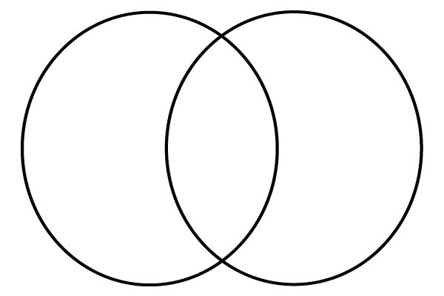  Different  Different  Different  Different  Different  Same
My Words  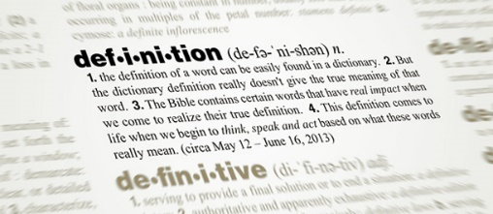  Define 15 vocabulary terms in your own words. | Flash Cards  Create flash cards for all vocabulary words with the word on one side of the index card and its definition on the other side.  Front Back  Guinea Pig A rodent originally from SA. | Crossword Puzzle  Create a crossword puzzle using 15 words. Be sure to include the definitions. Solve your crossword puzzle.  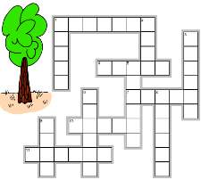
Current Event  Find an article from a magazine, newspaper, or online that involves one vocabulary word. Print out the article and summarize what the article was about in 6 to 8 sentences. | Mind Map  Create a mind map with the vocabulary word in the middle. Add at least 7 bubbles around the word with key words and/or examples that are associated with the vocabulary word. (Complete for 5 different words)  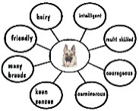 | Collage  Using illustrations, words, and/or magazine cut-outs, create a collage that depicts 1 of your vocabulary words thoroughly and creatively.  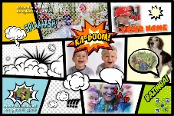
Letter  Write a letter to a person of your choice using at least 10 vocabulary words. Underline the vocabulary words in your letter. Make sure you demonstrate the meaning. | Figurative Language  Choose one type of figurative language below. Use 10 vocabulary words and write an example of each word using the figurative language you chose.  ➢ simile  ➢ metaphor  ➢ hyperbole  ➢ personification  ➢ onomatopoeia  ➢ oxymoron | Quiz Me!  Create a 10-question quiz that fully and thoughtfully assesses 10 vocabulary words. Include an answer key to your quiz. You do multiple choice or matching or fill in the blank, etc.
Vocabulary Choice Board
Choose 3 Below
15 Second Vocabulary Video

If you choose this option, you do NOT have to do the vocabulary choice board. For this option, you will create a 15 second vocabulary video for EACH vocabulary word. You can do this with friends, classmates, family, etc. If you work with a classmate, the grade will count for both of you and both of you should work on it together. Each video must have the following information included below:

REQUIREMENTS

— Each word must be pronounced and defined, and the part of speech must be given (noun, verb, etc.).
---Your video should be no more than 15 seconds BUT can be shorter.
— Use your imagination. You can act the word out, animate it, use puppets, draw, sing a song, create a dance, incorporate photographs, create a Claymation, or anything else that will help viewers understand and learn your word.
---You will need to upload the videos to your google account and share it with me OR save them to a flash drive for me to review.
** I may show your videos to our class throughout this unit.**

Need some examples? Go to youtube and type in 15 SECOND VOCABULARY. You can also type in:
https://youtu.be/4CJsDfVztbk
https://youtu.be/RT3hJy4lGow
https://youtu.be/vD6C-QoQ5yQ
https://youtu.be/xeyVujKwhOM
https://youtu.be/_kH4tJAKpJs
https://youtu.be/4xZBEcNPGRA

